CSA0619-Design and Analysis of Algorithm
CO4-AT2
CYBERSECURITY ACCESS CONTROL OPTIMIZATION USING SEARCH AND GRAPH ALGORITHMS
Aim:
To design and implement an optimized cybersecurity access control system using search and graph algorithms to securely manage user roles, permissions, access relationships, and security policies while analyzing its computational performance and scalability.
Problem Statement:
A corporate network must securely manage access permissions for different users. Each user has a specific role, and each resource requires an appropriate permission level. Unauthorized access must be prevented according to organizational security policies.
The system must:
- Model users and resources using graph structures.
- Define access relationships between users and resources.
- Apply role-based access control.
- Enforce security policies.
- Search for accessible resources efficiently.
- Identify access paths using graph algorithms.
- Support scalability for large organizations.
- Evaluate time and space complexity.

Objective
The main objective of this project is to develop a secure and efficient access control optimization system using graph and search algorithms.

The specific objectives are:
- To represent access relationships using a graph.
- To assign roles to users.
- To define permission requirements for resources.
- To implement security policy restrictions.
- To use BFS for searching access relationships.
- To find the shortest access path between users and resources.
- To analyze computational performance.
- To evaluate scalability for large corporate networks.
Algorithm
Access Permission Algorithm
- Start.
- Input user and resource.
- Check whether the user exists.
- Check whether the resource exists.
- Check whether a security policy denies access.
- Compare the user's role with the required resource role.
- If the user role has sufficient permission, grant access.
- Otherwise, deny access.
- Stop.
BFS Algorithm
- Start.
- Create a queue and add the starting user.
- Mark the user as visited.
- Remove a node from the queue.
- Visit all connected resources.
- Add unvisited nodes to the queue.
- Continue until all reachable nodes are visited.
- Stop.
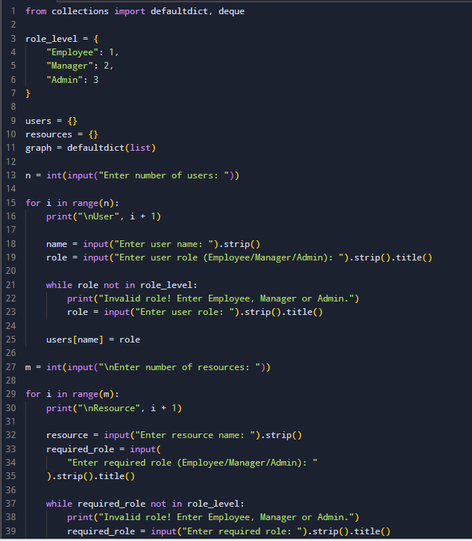
Source Code:

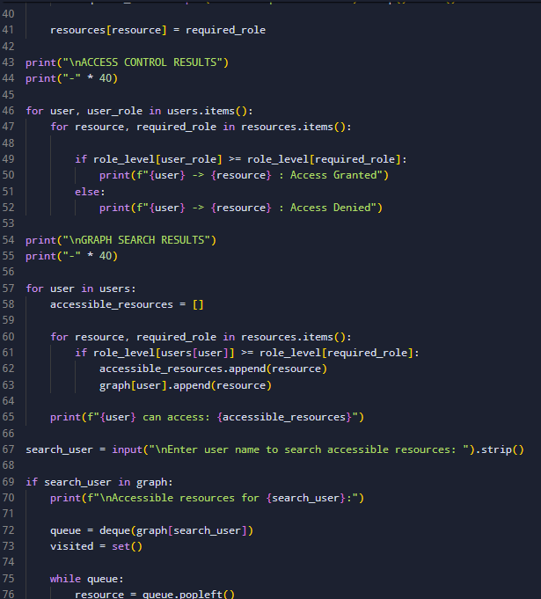

Output:
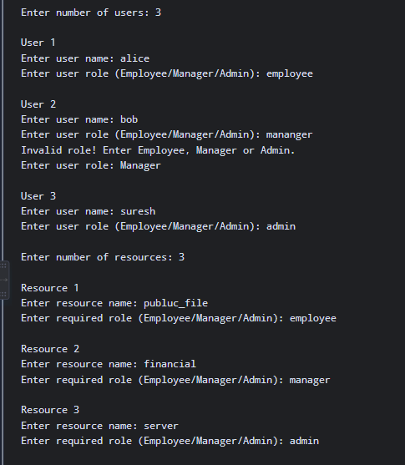

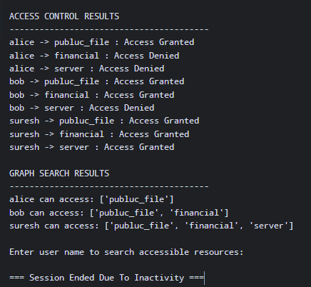

\
Time and Space Complexity
Access Permission Check
The dictionary and set operations are approximately constant time.
Time Complexity: O (1)
Space Complexity: O (U + R + P)
Where:
U = Number of users
R = Number of resources
P = Number of security policies
Breadth-First Search
In the worst case, BFS visits every vertex and edge.
Time Complexity: O (V + E)
Space Complexity: O(V)
Where:
V = Number of vertices
E = Number of edges
Shortest Access Path
The BFS shortest path algorithm also has:
Time Complexity: O (V + E)
Space Complexity: O(V)
Report Analysis
The Cybersecurity Access Control system is used to manage user permissions securely. The program checks the user's role and permission before allowing access to a resource. Graph algorithms are used to represent the connection between users and resources, while BFS is used to find accessible resources. The system allows authorized users and denies unauthorized users, improving and security.

